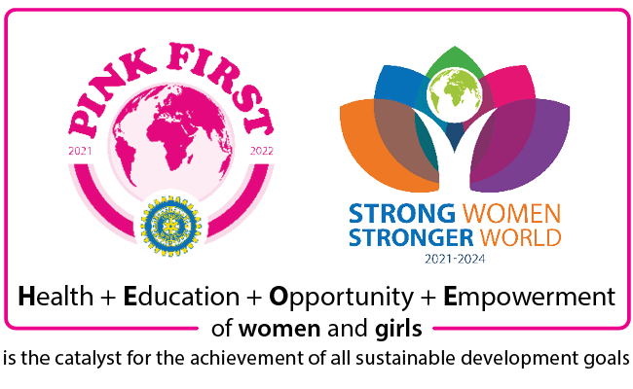

Form for Articles (version 21-22-1)
This form has two pages. If you have a longer write-up, it will grow to more pages when needed.
Use this form for submission of articles for IIW internet media or video for IIW YouTube. Please fill completely.
Author name
Author email |  |  | Mobile
Club name
Country |  |  | District number
Date of event
(or article)
(1) Title of article or video (in bold).
(2) Write-up of the article or description of video (not in bold and not in caps).
- Please describe your activity e.g. who, what, where, when, why, how.
- Avoid use of first person (I, we, my , our and short forms).
- If desired, insert <filename> in-text where photos are to appear in article.
- Your club name should appear somewhere in the write-up.
- Write in the style of promoting the event (journalism) and not as a report.
This document will grow as you add more words inside the box.
Photographs  - Provide a caption for the photo if it is not placed beside a descriptive part of the text.  - Do not paste photos into this document.  - You can add more rows for more photos.  - Filename is unique, 12 characters long, without space, consists of only letters or numbers.  Send photos as an attachment in the email, or via Dropbox (www.dropbox.com) or WeTransfer (www.wetransfer.com) | Filename of photo | Caption for photo
Link to dropbox or wetransfer for
video or photos

IMPORTANT: For all elements of the article or video, whether as a whole or in part, your club or your club member must be the copyright holder or licensed user. E.g. text, graphic, photo, video, music in video.

Please save this form in MSWord and attach it in email through the following protocol channels:
- to IIW Vice-President Zenaida Farcon for UN Representatives and Board Directors
- to National Editor (NGBs) or National Representatives (non NGB)
- to District Chairman (without NRs)
- to Board Directors (non-districted clubs) thence to IIW VP Zenaida Farcon

For any queries, please email to IIW Editor/Media Manager 2021-2022:
Cheng Yeok San iiweditor@internationalinnerwheel.org
An acknowledgement of receipt will be sent within 48 hours.
Whatsapp chat only: +60125186960 9AM to 5PM Kuala Lumpur GMT+8. (Please introduce yourself.)

